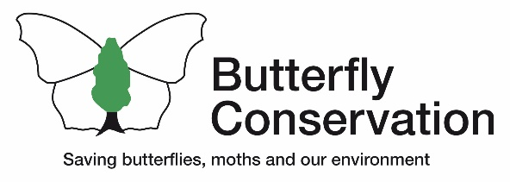

**Branch Chair**

|  |  |
| --- | --- |
| **Location:** | Home based, but with some travel in The Branch area. Occasional travel for regional and or national meetings. |
| **Purpose of role:** | * To lead and direct The Branch and its activities (delegating tasks to other Branch committee members and post-holders as needed) in accordance with the organisational strategy, branch guidelines and Butterfly Conservation’s policies. * To facilitate regular communication between Branches and Head Office and strengthen relationships within the Branch and across the organisation. |
| **Key Contact:** | Accountable to The CEO, however day to day supervision is delegated to The Director of Engagement and Volunteering |
| **Tasks:** | * Work with local partners, Head Office and other branch volunteers to deliver the organisational strategy in The Branch area. * Provide feedback to Head Office on progress towards the organisational strategy, reporting against specific KPIs when requested. * Disseminate information from Head Office to the Branch committee and other volunteers, as appropriate. * Chair regular Branch Committee meetings. * Share best practice and constructively challenge anything which prevents The Branch from delivering the organisational strategy. * Undertake succession planning for essential roles within The Branch, including that of Branch Chair. * Represent Butterfly Conservation at functions and meetings as appropriate. * Ensure that The Branch is operating legally and in accordance with the Branch Guidelines, Health and Safety policies and General Data Protection Regulation (GDPR). * Approve annual income and expenditure budgets for The Branch, as developed by Branch Treasurer. * Alert staff if anyone hears about sites under threat in branch area add support BC’s efforts to defend key sites within the Branch area. * Promote equality, diversity and inclusion within The Branch. |
| **Dates, times, commitment and frequency:** | This role is active throughout the year. There is flexibility on which days and times you volunteer, however you may occasionally be asked to attend meetings or visit sites at specific times.  We ask for a minimum commitment of 1 year. You will be asked to participate in an induction session and essential training for the role, which will be carried out online where possible. |
| **Skills and abilities needed:** | * A broad understanding of butterflies, moths and their habitats in the UK. * Good communication skills * Able to work with a wide range of people in a personable and professional manner. * Able to delegate tasks to others. * Able to use basic IT systems, such as the internet, video calls, word processing software etc., - and a willingness to learn how to use new systems as required. * Able to represent Butterfly Conservation and it’s values, using language which builds trust, encourages forward thinking and creates energy within the branch. * You may find it useful to have access to your own transport to visit remote sites, though this is not a pre-requisite for the role. Use of public transport and car sharing is encouraged. * You must be able to access the internet as required, including during the evenings and at weekends. |
| **Benefits and support provided:** | In addition to the many [general benefits of volunteering with us](https://butterfly-conservation.org/how-you-can-help/get-involved/volunteering), this role also provides the opportunity to:   * Discover new sites, partnerships and communities. * A platform to have a voice, build your profile and connections in conservation. * Develop your volunteering portfolio in a unique and sought-after role. * Develop, use or evidence key leadership skills.   Why does it matter? This key role helps us to involve more people in the conservation of butterflies and moths, increasing the impact of the organisation. |